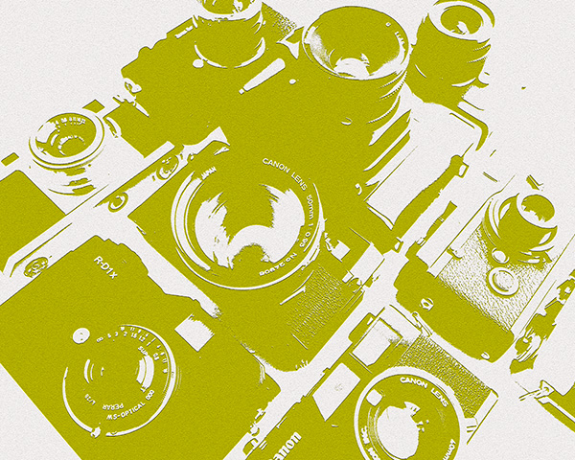
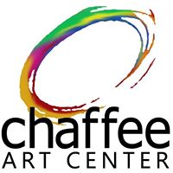

Annual Amateur

Photo Contest

as part of our
14th Annual Student Exhibit
& Digital Expression
April 23 to June 4, 2021

Photo Contest Theme:
Expressions of Me

Contest Guidelines:

Amateur photographers only, all ages welcome.

DEADLINE APRIL 17th. All photos must be 8” x 10”and taken by the person submitting this form. Please mount/ frame your photos if possible. All photos submitted will be listed for sale at $40 with 50% of the sale paid to the artist.

Photos in the theme “Expressions of Me” preferred. Photo must not be staged or altered by photo editing software beyond, resizing/cropping accepted. $10 donation for up to 3 photographs is requested and due upon delivery. Please make checks payable to: Chaffee Art Center. Let us know of special circumstances.

Limit of 3 photos per person, please prioritize photos in order of preference. Due to limited space all submitted photos are not guaranteed to be hung. Preference will be given to number 1 photos. The contest organizers reserve the right to select photos for the contest. Please attach an entry slip to each photo giving name, age, title, email, phone.

Any photos that are unsold must be picked up by June 4, 2021 by 4pm or will become property of the Chaffee Art Center to dispose of as we wish.

Dates to Remember:
Submission Drop-off: April 16th from Noon to 4pm and April 17th 10am to 2pm. [Note: Visit Chaffee Facebook page for more details. Depending on pandemic restrictions, there may be further drop off times and specific instructions.]

Exhibition opens & public voting begins: April 23rd
Artwork Pick-up: June 4, 11am to 4pm.

AWARDS GIVEN TO:
1st and 2nd Overall. Plus, a People’s Choice award in each category below.

CATEGORIES:
Youth 12 & under, Teen 13-18, Adult 18+

Submission may also be mailed to: Chaffee Art Center, 16 South Main St., Rutland, VT 05701

Visit our website www.chaffeeartcenter.org for more information.
Inquiries or to get a form emailed: info@chaffeeartcenter.org or (802) 775-0356.
PHOTO CONTEST SUBMISSION FORM
14th Annual Photo Contest
Expressions of Me

This photo is priority _____1
Name_____________________________________________________Email______________________________________
Address_____________________________________________City___________________State_________Zip_____________Phone__________________________ Photo Title______________________________________________________________
Please read and sign below:
I understand that the contest organizers reserve the right to select the photos for the Annual Photo Contest. I also understand that all contest photos will be for sale with 50% of the proceeds benefitting the artist. I understand and accept that any photographs not picked up by June 4, 2021 will become the property of the Rutland Area Art Association, and may be used or disposed of as they deem, including be sold with 100% of the proceeds benefiting the Rutland Area Art Association. Any income derived from the use of the photos will support programs at the Chaffee Art Center. Any use of a photo will credit the photographer. I understand that this may be exhibited for public events. I further understand that only photos of the theme “Expressions of Me” will be accepted for the contest. I agree to comply with all contest guidelines outlined on entry form.

Signed___________________________________________________________Date___________________________________
-----------------------------------------------------------------------------------------------------------------------------------------------------------
This photo is priority _____2
Name_____________________________________________________Email______________________________________
Address_____________________________________________City___________________State_________Zip_____________Phone__________________________ Photo Title______________________________________________________________
Please read and sign below:
I understand that the contest organizers reserve the right to select the photos for the Annual Photo Contest. I also understand that all contest photos will be for sale with 50% of the proceeds benefitting the artist. I understand and accept that any photographs not picked up by June 4, 2021 will become the property of the Rutland Area Art Association, and may be used or disposed of as they deem, including be sold with 100% of the proceeds benefiting the Rutland Area Art Association. Any income derived from the use of the photos will support programs at the Chaffee Art Center. Any use of a photo will credit the photographer. I understand that this may be exhibited for public events. I further understand that only photos of the theme “Expressions of Me” will be accepted for the contest. I agree to comply with all contest guidelines outlined on entry form.

Signed___________________________________________________________Date___________________________________
-----------------------------------------------------------------------------------------------------------------------------------------------------------
This photo is priority _____3
Name_____________________________________________________Email______________________________________
Address_____________________________________________City___________________State_________Zip_____________Phone__________________________ Photo Title______________________________________________________________
Please read and sign below:
I understand that the contest organizers reserve the right to select the photos for the Annual Photo Contest. I also understand that all contest photos will be for sale with 50% of the proceeds benefitting the artist. I understand and accept that any photographs not picked up by June 4, 2021 will become the property of the Rutland Area Art Association, and may be used or disposed of as they deem, including be sold with 100% of the proceeds benefiting the Rutland Area Art Association. Any income derived from the use of the photos will support programs at the Chaffee Art Center. Any use of a photo will credit the photographer. I understand that this may be exhibited for public events. I further understand that only photos of the theme “Expressions of Me” will be accepted for the contest. I agree to comply with all contest guidelines outlined on entry form.

Signed___________________________________________________________Date___________________________________

